
American International University-Bangladesh (AIUB)
Department of Computer Science
Faculty of Science &Technology (FST)
Summer 25_26
Section: A
Software Quality Assurance and Testing
PROJECT TITLE
Digital MeatBzar
A Report submitted
By

SN | Student Name | Student ID
1 | Mazumder Redwanul Haque | 22-48481-3

Checked By Industry Personnel (Optional)

Name:

Designation:

Company:

Sign:

Date:

Software Test Plan

for

<Digital MeatBazar>
Version 1.0 approved
Prepared by Mazumder Mazumder Redwanul Haque>
<American International University-Bangladesh (AIUB)>
<31 August 31, 2026 >

Table of Contents
Revision History 3
1. TEST PLAN IDENTIFIER:RS-MTP01.3 4
2. REFERENCES 4
3. INTRODUCTION 4
3.1 Background to the Problem 4
3.2 Solution to the Problem 4
Purpose of the Document 5
4. REQUEIREMNT SPECIFICATION 5
4.1 System Features 5
4.1.1 Authentication & Authorization of users …………………………………………………6
4.1.2 Product Catalog Management …………………………………………………………….6
4.1.3 Shopping Cart Management ……………………………………………………………...6
4.1.4 Payment Management …………………………………………………………………….6
4.1.5 Order Management ……………………………………………………………………….6
4.1.6 Admin Dashboard & Management ……………………………………………………….6
4.1.7 Distributor Management ………………………………………………………………….6
4.1.8 Inventory Management …………………………………………………………………...6
4.1.9 Profile Management ………………………………………………………………………6
4.1.10 Contact & Supporting Pages ……………………………………………………………...6
4.2 System Quality Properties 12
4.3 System Interface 15
4.4 Project Requirements 15
5. FEATURES NOT TO BE TESTED 16
6. TESTING APPROACH 17
6.1 Testing Levels 17
6.2 Test Tools 18
6.3 Testing Environment 18
6.4 Meetings and Communication 18
6.5 Defect Management 18
7. TEST CASES/TEST ITEMS 19
8. ITEM PASS/FAIL CRITERIA 28
9. TEST DELIVERABLES 28
10. STAFFING AND TRAINING NEEDS 29
11. RESPONSIBILITIES 29
12. TESTING SCHEDULE 30
13. PLANNING RISKS AND CONTINGENCIES 30
14. APROVALS 31

Revision History
Revision | Date | Updated by | Update Comments
01 | 06-09-2026 | Mazumder Redwanul Haque | First Draft (Introduction, Problem Background, and Project Overview)
02 | 10-09-2026 | Mazumder Redwanul Haque | Second Draft (Requirement Specification and System Features)
03 | 11-09-2026 | Mazumder Redwanul Haque | Fourth Draft (Testing Schedule, Risks, Responsibilities, and Budget Estimation)
04 | 11-09-2026 | Mazumder Redwanul Haque | Final Version Approved (Review, Corrections, and Complete Software Test Plan)

TEST PLAN IDENTIFIER
TP_DigitalMeatBazar_1.0

REFERENCES
- Digital MeatBazar Project Repository.
- Software Quality Assurance and Testing (SQAT) Course Template.
- IEEE 829 Standard for Software Test Documentation.
- Digital MeatBazar Database and System Documentation.

INTRODUCTION

Background to the Problem
The traditional meat purchasing process in Bangladesh often requires customers to physically visit markets, which can be time-consuming and inconvenient. Consumers face challenges in finding quality meat products, comparing prices, tracking orders, and receiving reliable home delivery services. In addition, many meat suppliers still maintain manual inventory records and order management procedures, which increase the possibility of data inconsistency, delivery delays, and administrative errors. Managing customers, products, deliveries, and orders manually become increasingly difficult as business volume grows. Therefore, an automated and centralized system is required to streamline meat ordering, inventory management, customer management, and delivery operations.

Solution to the Problem
Digital MeatBazar is a web-based meat ordering and distribution management platform developed to automate the entire meat purchasing process.
The platform provides:
- Online customer registration and authentication.
- Product browsing by categories such as Beef, Chicken, Mutton, and Featured Products.
- Shopping cart and checkout functionality.
- Multiple payment methods including Cash on Delivery and Online Payment.
- Order tracking and status management.
- Inventory management.
- User, Admin, and Distributor management.
- Order assignment and delivery management.
- Revenue and order statistics dashboard.
The system supports three user roles:
User
- Register account
- Login
- Browse products
- Add products to cart
- Place orders
- Manage profile
- View order history
Admin
- Manage users
- Manage distributors
- Manage admins
- Manage inventory
- View and assign orders
- Monitor revenue and statistics
Distributor
- Receive assigned orders
- Update delivery progress
- Mark orders delivered
- Manage inventory
- View customer information

Purpose of the Document
This Software Test Plan outlines the testing strategy for the Digital MeatBazar platform. It defines the scope of testing, system requirements, test cases, testing procedures, and resources required to ensure the system functions correctly and meets quality standards. The plan focuses on validating core features such as user authentication, product management, shopping cart operations, payment processing, order management, inventory management, and distributor assignment. It is intended for developers, testers, project supervisors, and other stakeholders involved in the development and quality assurance of the system.

REQUEIREMNT SPECIFICATION

System Features

Authentication and Authorization of users
Priority: High
Precondition:
- Users must exist in the database.
- Database connection must be active.
Functional Requirements
User Registration
- The system allows users to create accounts.
- Username must be unique.
- Email must be unique.
Login System
- Users can log in using username and passwords.
- Separate authentication is provided for:
  - User
  - Distributor
  - Admin
Session Management
- Session is created after successful login.
- Session data stores user information.
- Logout destroys the active session.

Role-Based Access Control (RBAC):
- Users access customer functions.
- Distributors access delivery functions.
- Admins access administrative functions.
Profile Management:
Users can:
- View profile
- Update personal information
- Change password
Password Change:
- Users can change their password by entering a new one.
- The new password will be safely stored in the system after being verified.

Product Catalog Management

Priority: High

Precondition:
- Inventory data exists.
Functional Requirements:
The system displays products by category:
  - Featured Products
  - Beef
  - Chicken
  - Mutton
Users can:
  - View products
  - See price
  - Add products to cart

Shopping Cart Management
Priority: High
Functional Requirements:
- Customers can select quantities, add items to the cart, review their selections and calculate order totals.

Payment Management

Priority: High

Functional Requirements:

When customers go through the payment interface, they must use the supported payment methods and invalid payment information must not result in an order being confirmed incorrectly.

Order Management

Priority: High

Functional Requirements:
- After a valid checkout/payment flow, the system produces orders. The system provides order success and order history information.

Admin Dashboard and Management

Priority: High

Functional Requirements:
- Administrative modules allow admins to manage admins, users, inventory and all orders.

Distributor Management

Priority: High
Functional Requirements:

- The distributor module includes distributor profiles, inventory, assigned orders and order processing.

Inventory Management

Priority: High

Functional Requirements:
- Authorized administrative/distributor users can manage inventory information.

Profile Management
Priority: Medium

Functional Requirements:
- Authenticated users may view and edit their permitted personal information.

Contact and Supporting Pages

Priority: Medium

Functional Requirements:
- Supporting pages like contact, logout and password recovery should work as per intended flow.

System Quality Attributes

User Experience
- The website should provide simple and easy navigation for customers.
- Product browsing, cart management, and checkout processes should be user-friendly.
- Users should receive clear success, warning, and error messages for their actions.
- The interface should be responsive and accessible on different screen sizes.
Security
- Authentication and authorization mechanisms should prevent unauthorized access.
- User passwords should be stored securely using encryption or hashing techniques.
- Payment information and account transactions should be properly validated before processing.
- Database operations should use secure methods to prevent SQL Injection, XSS, and other common web vulnerabilities.

Reliability
- Cart, order, inventory, and payment information should remain consistent across the system.
- System failures should not generate incorrect orders or duplicate transactions.
- Inventory updates should accurately reflect product availability after each order.
- The system should maintain data integrity during all operations

Compatibility
- The website should function correctly on major desktop browsers such as Chrome, Firefox, Edge, and Safari.
- The system should support common screen resolutions and responsive layouts.
- All core features should perform consistently across supported browsers.
Maintainability
- PHP modules should remain organized and modular for easier maintenance.
- Database access should be managed through centralized connection files.
- New features and updates should be integrated without affecting existing functionality.
- Source code should be properly documented and structured to support future development.
Scalability
- The system should support an increasing number of users, products, and orders.
- Database structures should accommodate future business growth.
- Additional modules and features should be integrated with minimal changes to the existing system.
Availability
- The platform should remain available whenever customers need to browse products or place orders.
- System errors should be handled gracefully without affecting critical operations.
- Backup and recovery procedures should be available to minimize data loss.

Flexibility
- Product Management: Administrators can add, update, or remove meat products, categories, and pricing without modifying source code.
- Order Management: Admins can assign distributors, update order status, and manage deliveries through the dashboard.
- Extensibility: The modular architecture allows the addition of new product categories, payment methods, and delivery features.
- Configuration: Database credentials and application settings are maintained through centralized configuration files.
- Deployment: The system can be deployed and maintained easily using XAMPP, Apache, and MySQL environments.
Interoperability
- Database: MySQL is used for storing user, product, cart, order, inventory, and payment information.
- Web Server: The application is compatible with Apache servers through XAMPP.
- Backend: Developed using PHP for business logic and database interaction.
- Front-end: Implemented using HTML, CSS, and JavaScript to ensure compatibility with standard web browsers.

Performance
- Fast Product Loading: Product pages should load within an acceptable time in the testing environment.
- Efficient Cart Operations: Adding, updating, and removing products from the cart should be processed quickly.
- Optimized Database Queries: Product, order, and inventory retrieval should be optimized for better response times.
- Order Processing: Checkout and payment confirmation should be completed without unnecessary delays.

System Interface
The system interface includes customer pages, product pages, cart and payment pages, authentication/profile pages, an administrator dashboard and distributor management pages. The provided project has dedicated PHP pages to provide these functions.

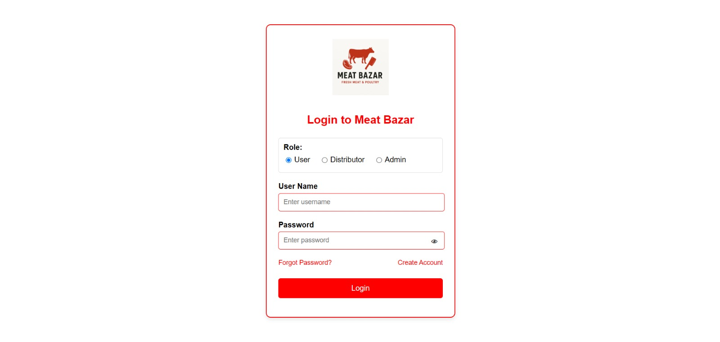
Interface 01: Login page
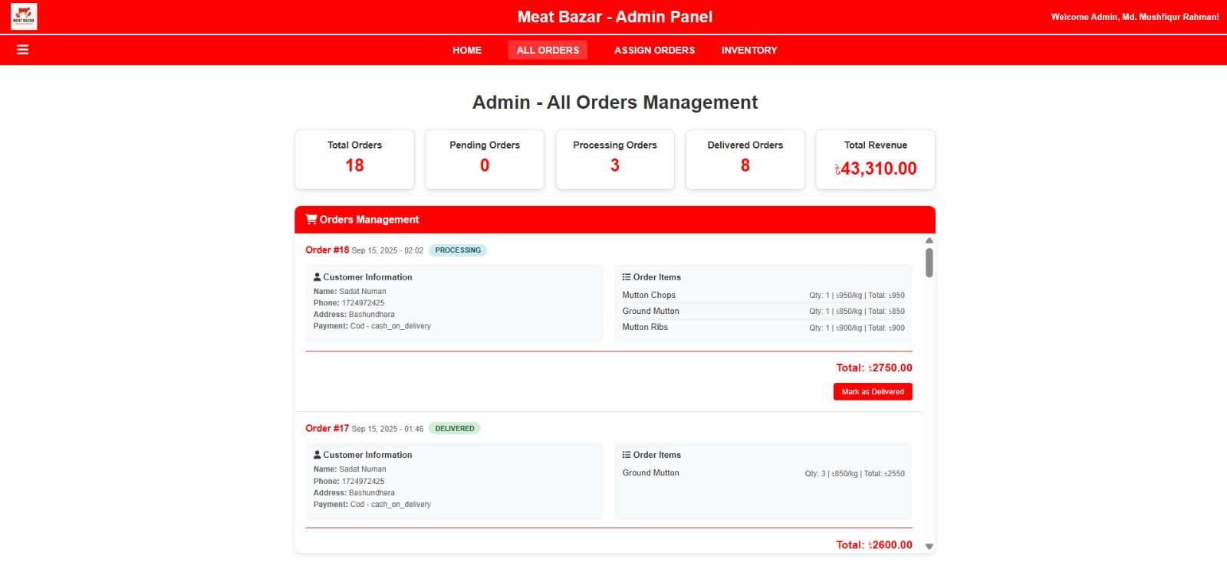
Interface 02: Admin Order Management
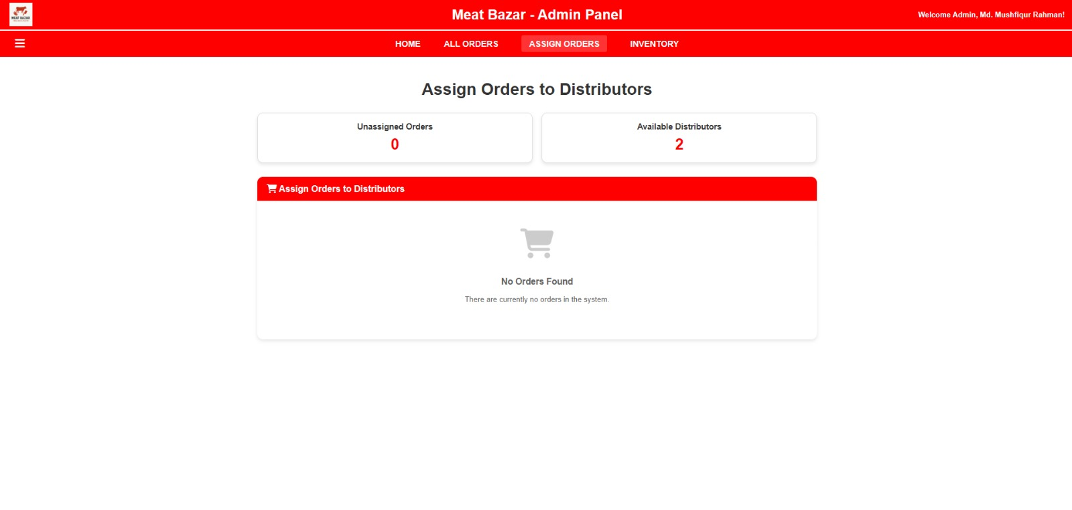
Interface 03: Admin Orders to Distributors Panel

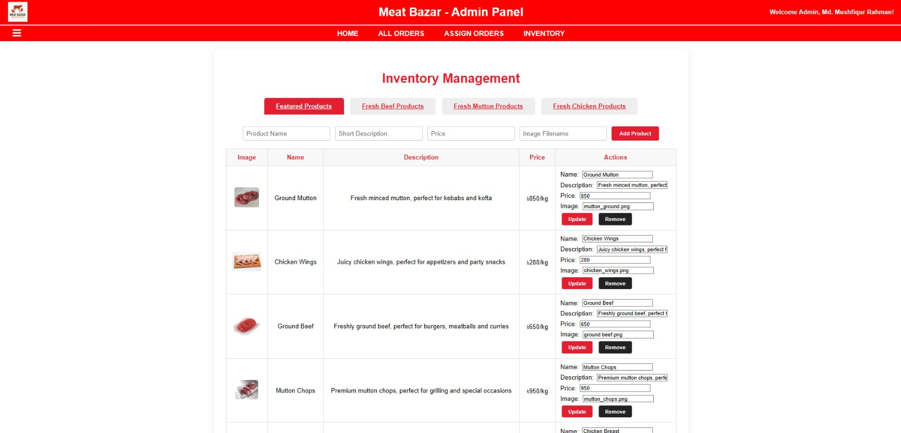
Interface 04: Admin Inventory Management

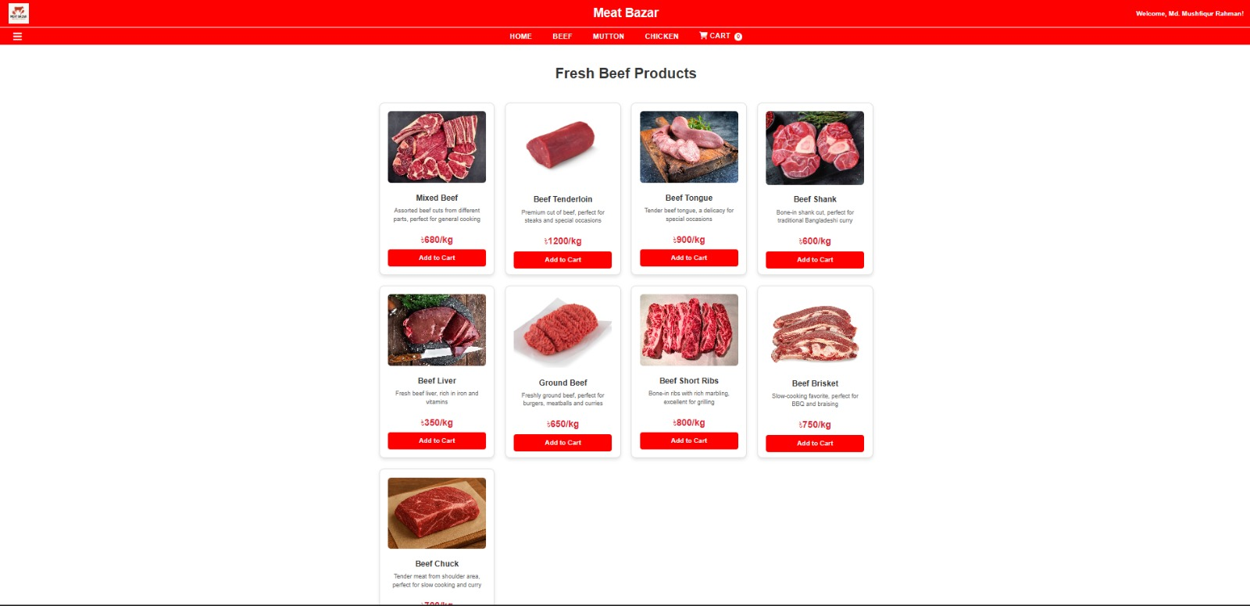
Interface 05: Beef product Homepage

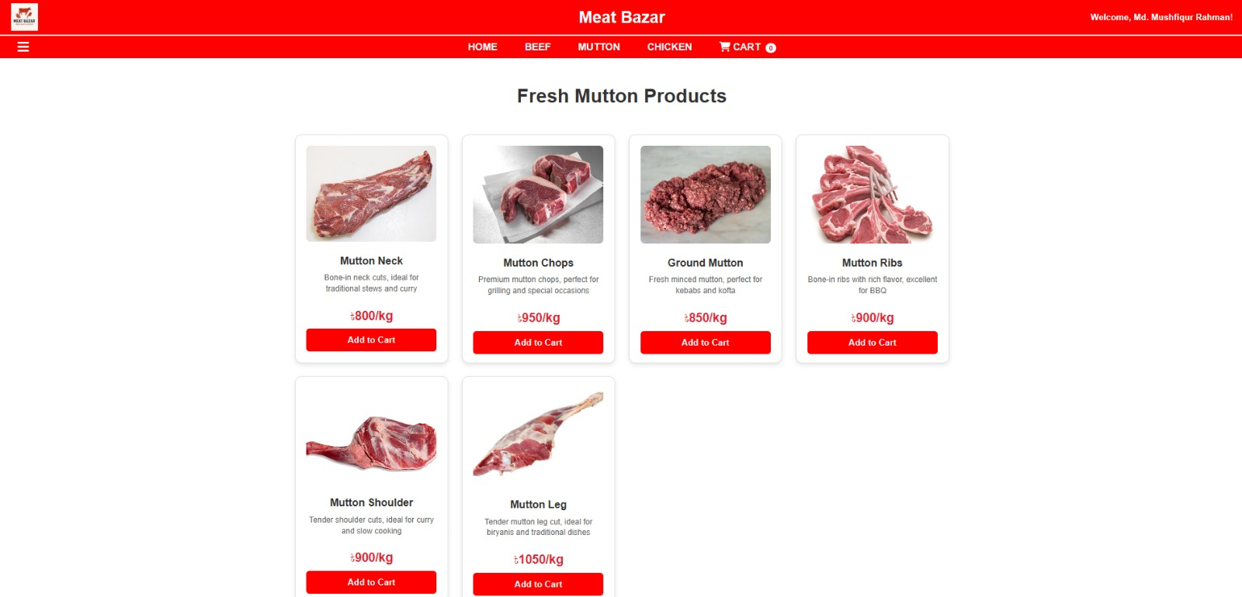
Interface 06: Mutton product Homepage

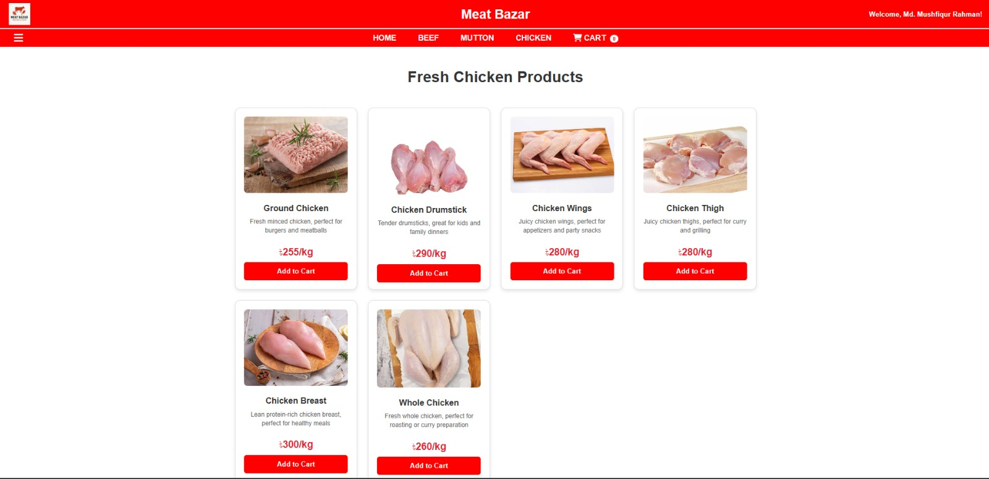
Interface 07: Chicken product Homepage

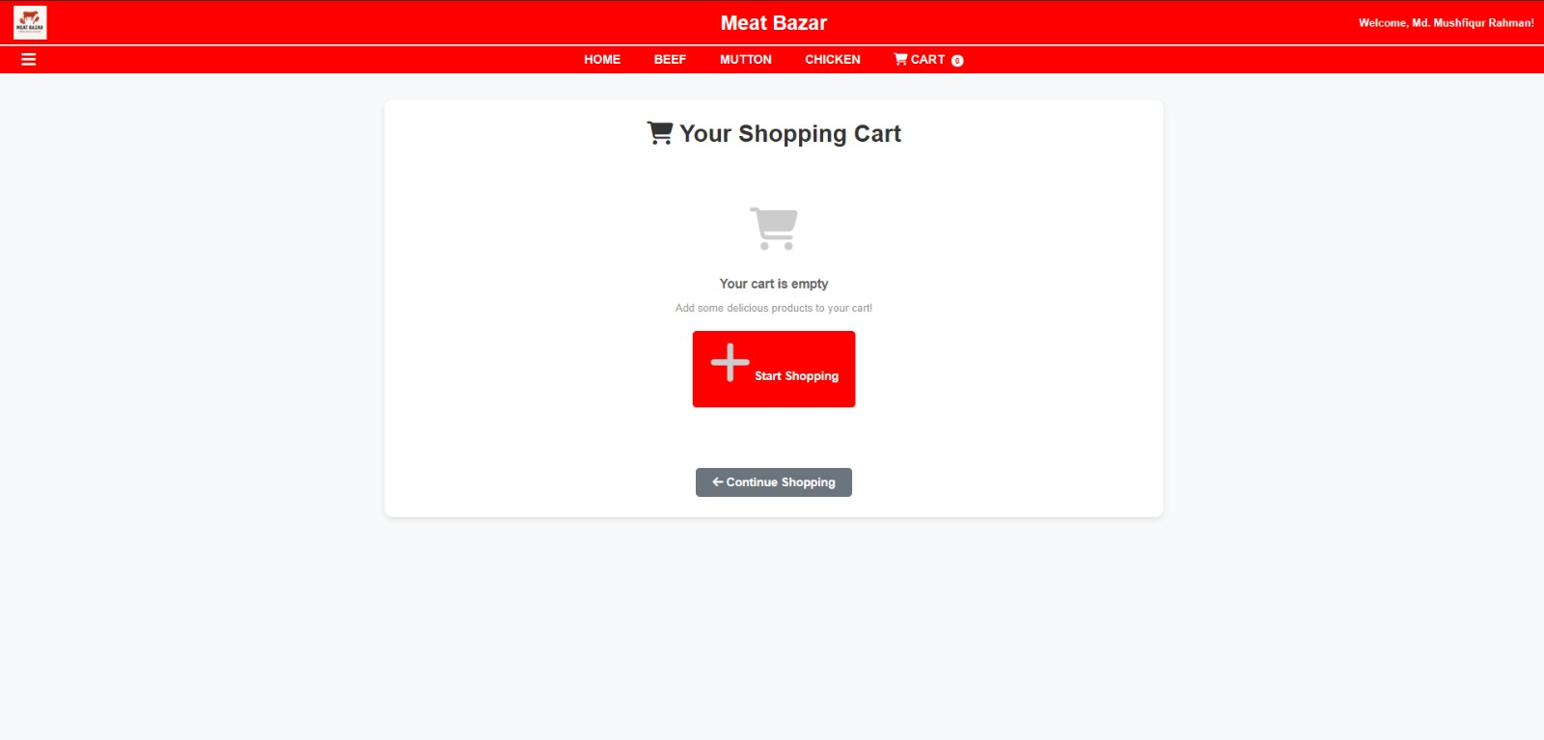
Interface 08: Add to cart

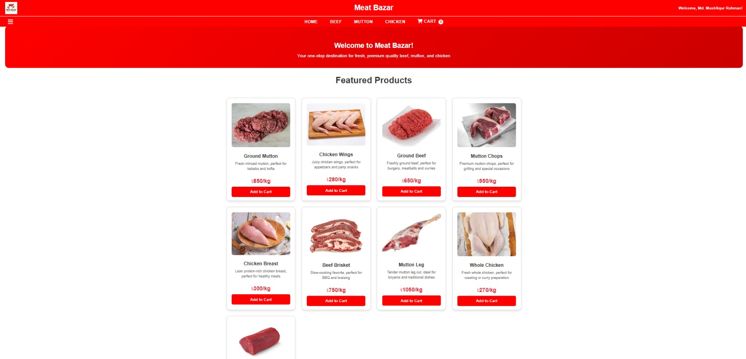
Interface 09: All product Homepage

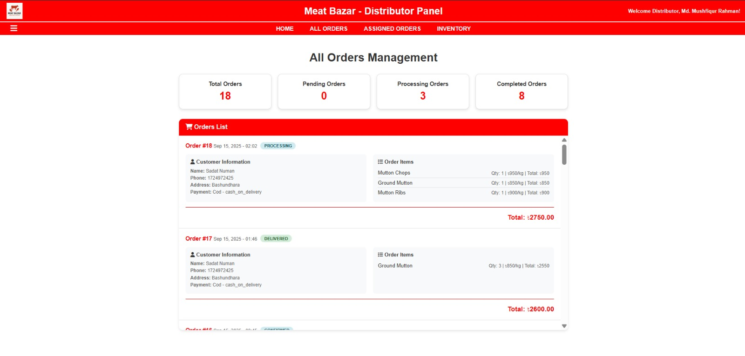
Interface 10: Distributor Orders Management Panel
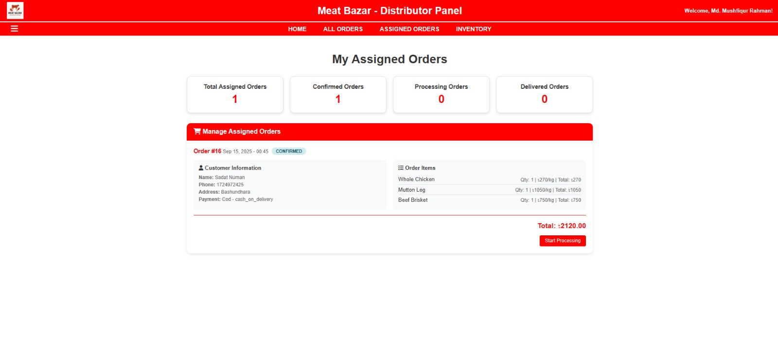
Interface 11: Distributor Assigned Order Panel
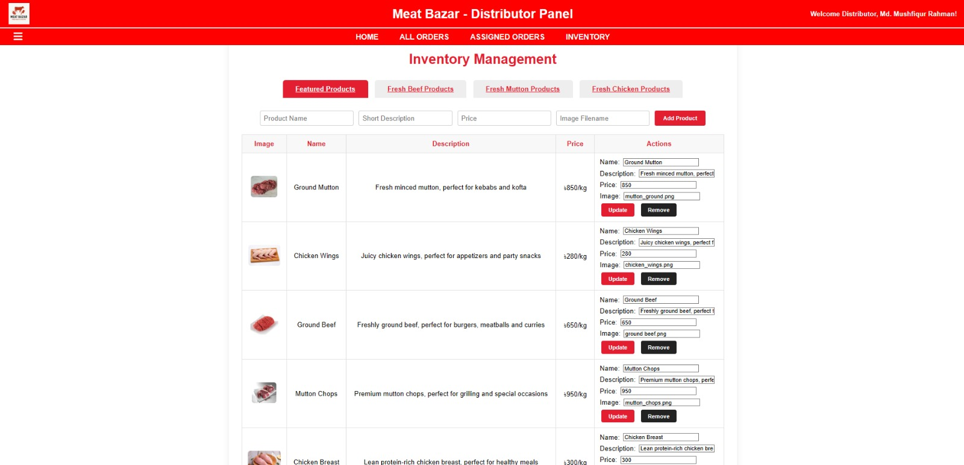
Interface 12: Distributor Inventory Management Panel

Project Requirements
Time Estimation
The whole development timeline including testing and deployment should be around two months. The main phases are:

Phase | Duration | Key Activities
Requirement Analysis & Planning | 1 week | Gather stakeholder requirements, define project scope, and establish milestones.
UI/UX Design | 1.5 weeks | Design the dark-themed administrative panel and responsive public webpages.
Database & Backend Development | 2 weeks | Design seven core database tables, implement authentication develop migrations, and construct APIs.
Frontend Development | 1.5 weeks | Implement SPA routing, public pages, contact form, CSS,
Integration & Testing | 1.5 weeks | Conduct unit, integration, security, and cross-browser compatibility testing.
Deployment & Bug Fixing | 1 week | Configure hosting, deploy the system, and resolve deployment-related issues.
Final Review & Launch | 3 days | Perform final QA, user acceptance testing, documentation review, and system release.

Budget Estimation
Resource | Calculation | Cost
Backend Developer (PHP, MySQL) | 50,000 × 2 months | 100,000 BDT
Frontend Developer (HTML/CSS/JS) | 40,000 × 1.5 months | 60,000 BDT
UI/UX Designer | One-time fee | 10,000 BDT
Manual Tester | One-time fee | 10,000 BDT
Total |  | 180,000 BDT

This project is meant to be run locally using XAMPP (Apache/PHP and MySQL). Project archive contains files of PHP application, product/logo images, database connection file and database setup functionality.

Requirement | Description
Server | XAMPP with Apache and MySQL
Backend | PHP
Database | MySQL
Frontend | HTML, CSS and JavaScript
Main Roles | Customer, Administrator, Distributor
Main Business Areas | Products, Cart, Payment, Orders, Inventory, User/Admin/Distributor management

FEATURES NOT TO BE TESTED
The application test scope for the current testing cycle does not include the internal behaviour of XAMPP, Apache, PHP runtime, MySQL internals and third-party browser engines. Native mobile applications, production hosting infrastructure, and external payment provider back-end systems are also out of immediate scope unless the project provides an integration environment for them. The testing will be focused on the own interfaces of the Meat Bazar application, interaction with the database, validation, role restrictions and end to end business flows.

6.TESTING APPROACH

6.1 Testing Levels
Unit testing will be performed on individual PHP functions, validation logic, calculations and database operations. Integration testing will verify the interaction between the module’s authentication, products, cart, payment, order, inventory and role. System testing will validate the complete customer, admin and distributor workflows. Security Testing will test for Authorization, Input validation and common web vulnerabilities. Usability and compatibility tests will look at navigation, feedback and behavior on various browsers and screen sizes. The acceptance testing will confirm that the key project requirements have been met.
6.2 Test Tools
- Browser developer tools for manual inspection / debugging.
- XAMPP for Apache / PHP / MySQL execution.
- Checking the database with MySQL tools/phpMyAdmin.
- Selenium for web test automation (where applicable to the project)
- Versioning/source control was done using Git/GitHub.
6.3 Testing Environment
The testing will be done mainly in a Windows desktop environment with XAMPP, a web browser, PHP and MySQL. Now the application will be accessible from the localhost and the project directory. Test data will be generated for customer, administrator, distributor, product, cart and payment and order scenarios.
6.4 Meetings and Communication
Project team will review test progress, failed cases, defects and retest results during testing. Any critical issue that affects payment, authorization, order creation or data integrity should be communicated immediately.
6.5 Defect Management
Defects will be recorded with test case ID, module, reproduction steps, expected result, actual result, severity and status. Critical defects are Failures that lead to Unauthorized Access, Incorrect Payment Confirmation, Major Data Corruption or System Crash. Major defects impact key business functions. Minor problems with poor functionality or user interface behavior. Cosmetic defects are problems of presentation.

7. TEST CASES / TEST ITEMS
FR_01: Verify login with valid username and password
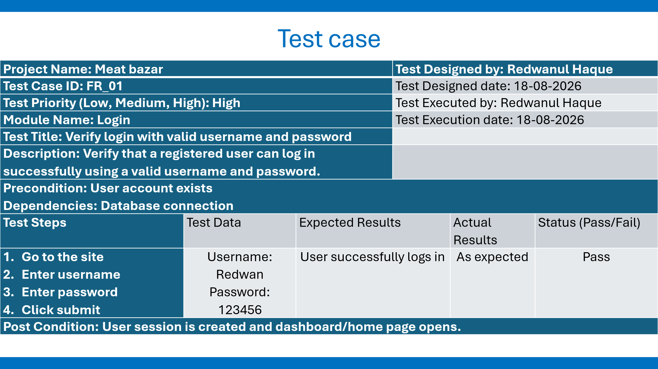
FR_02: Verify login with invalid password
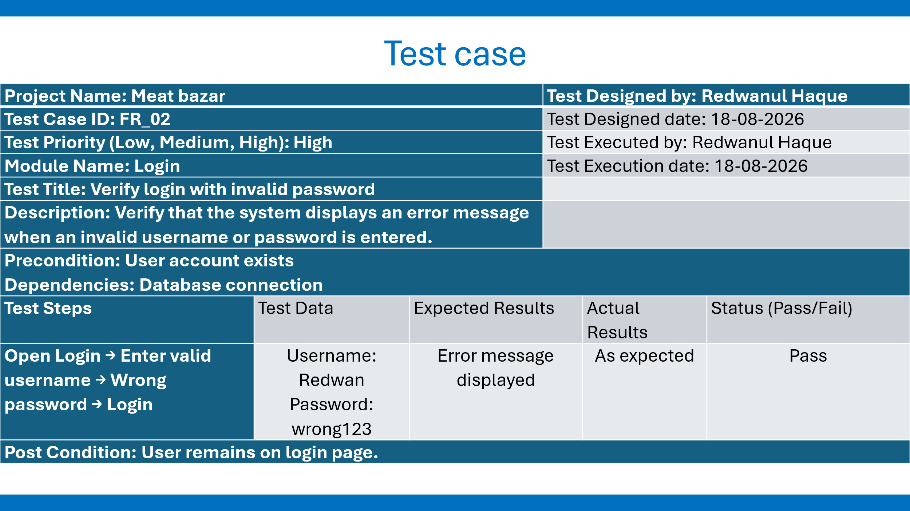
FR_03: Verify new user registration
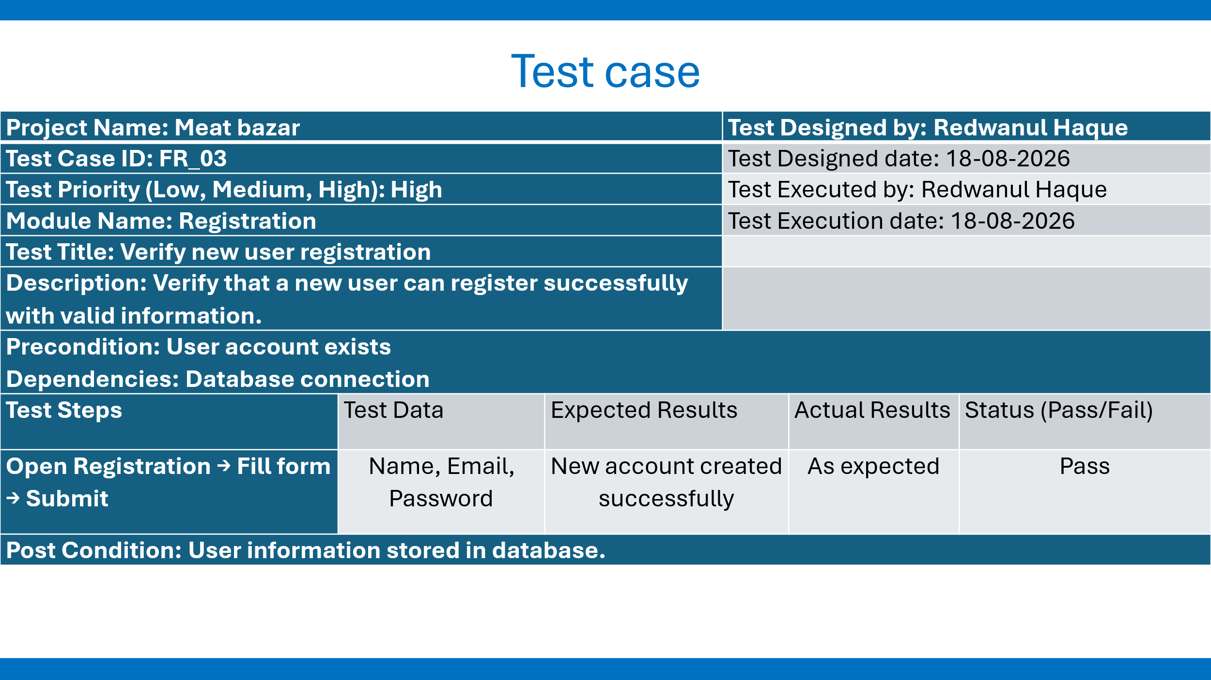
FR_04: Verify product search
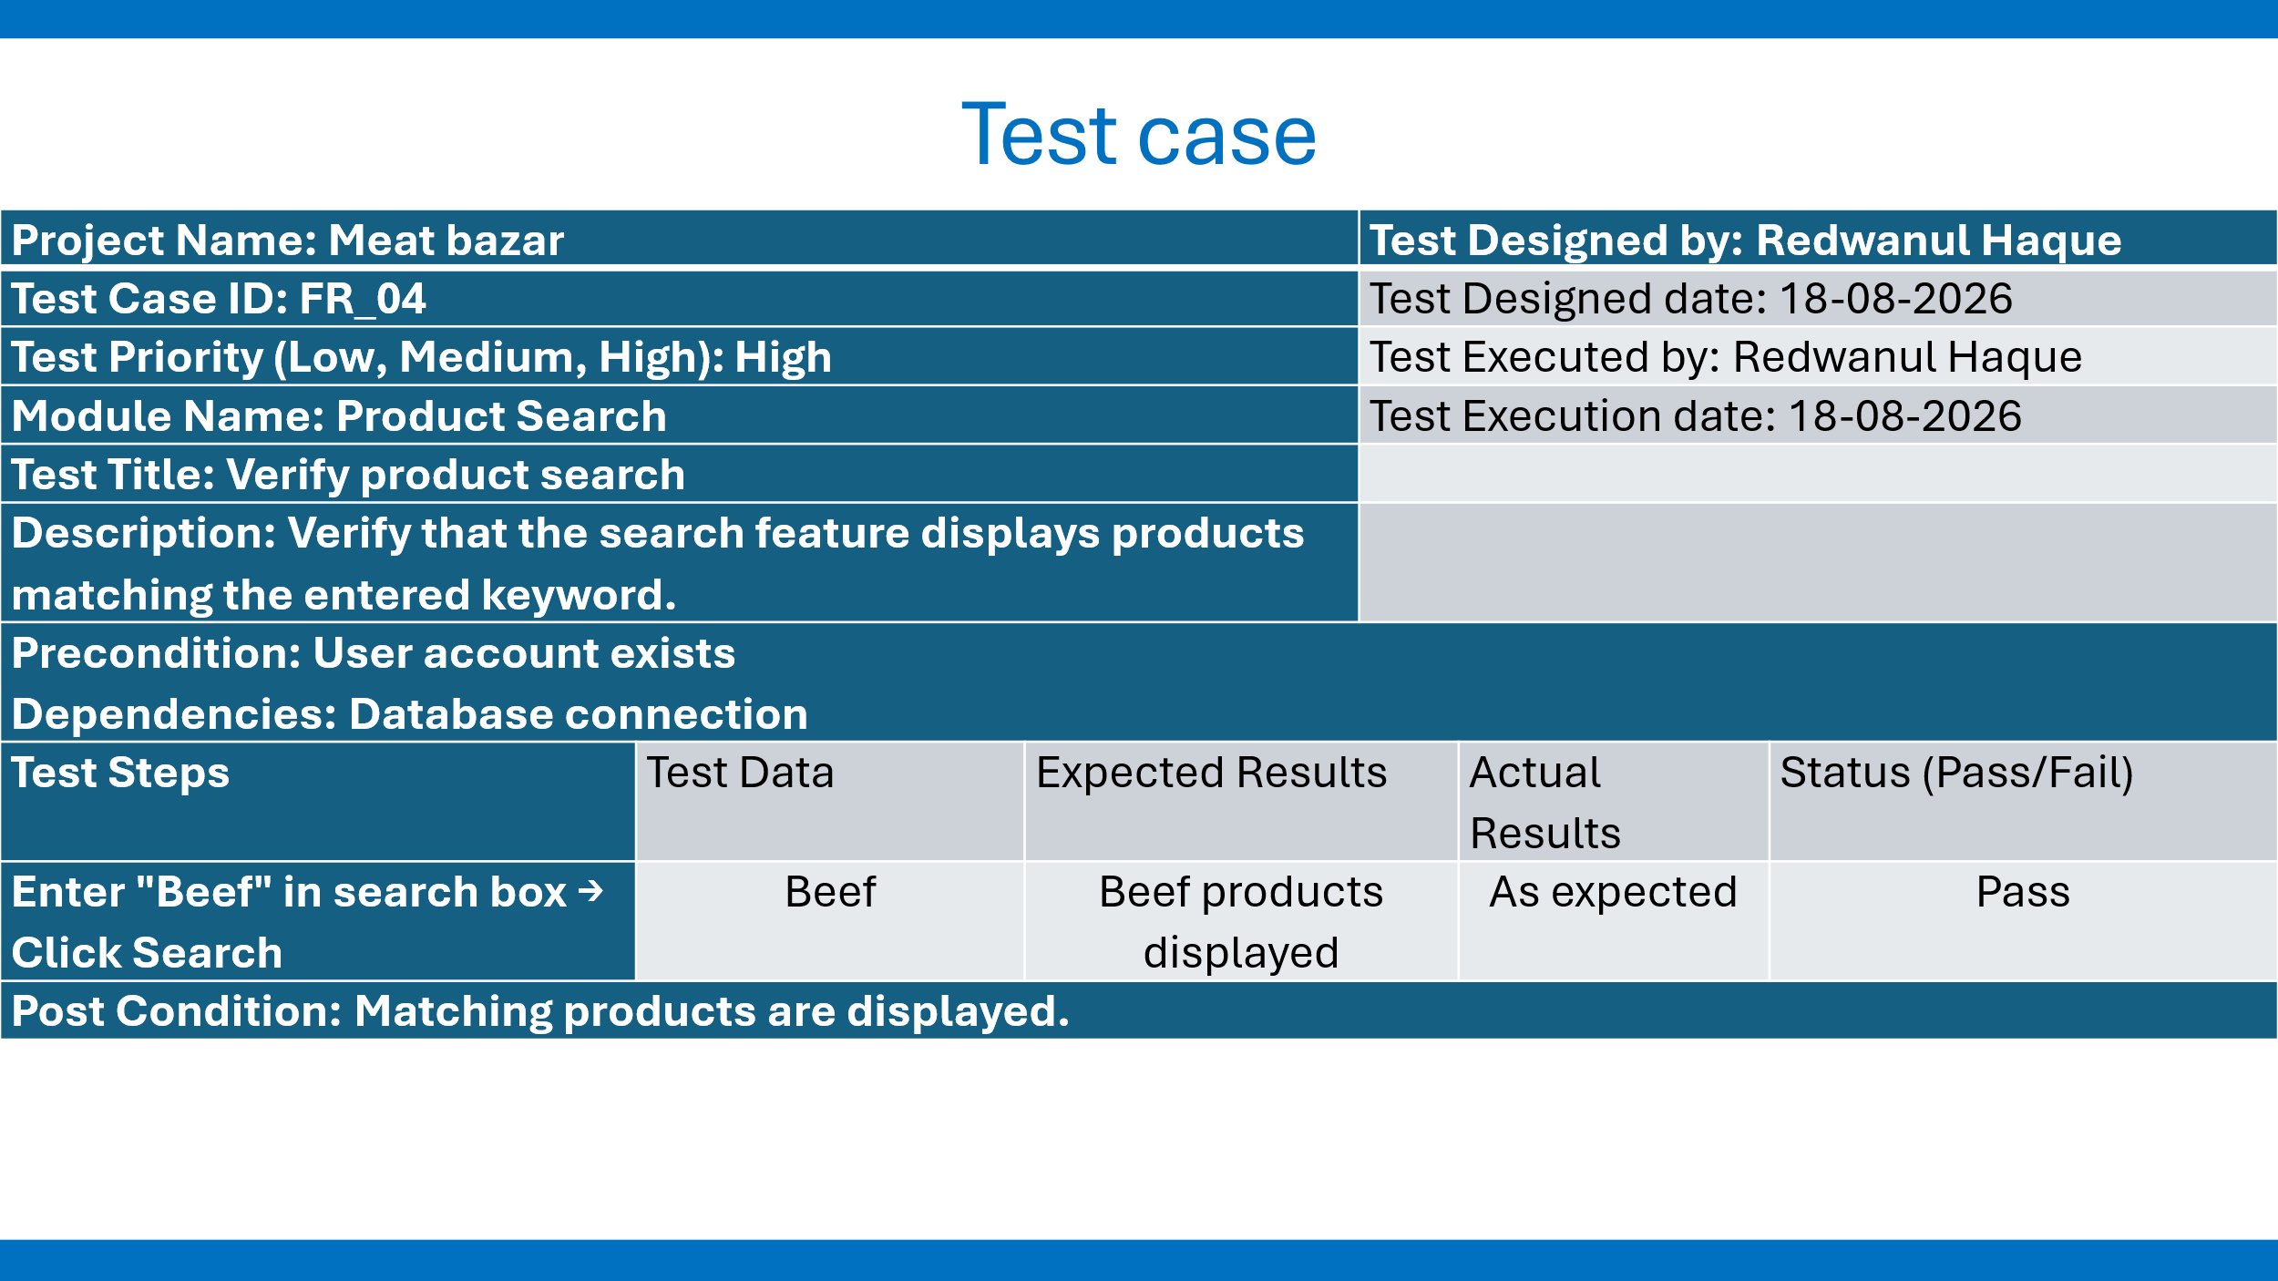

FR_05: Verify product information
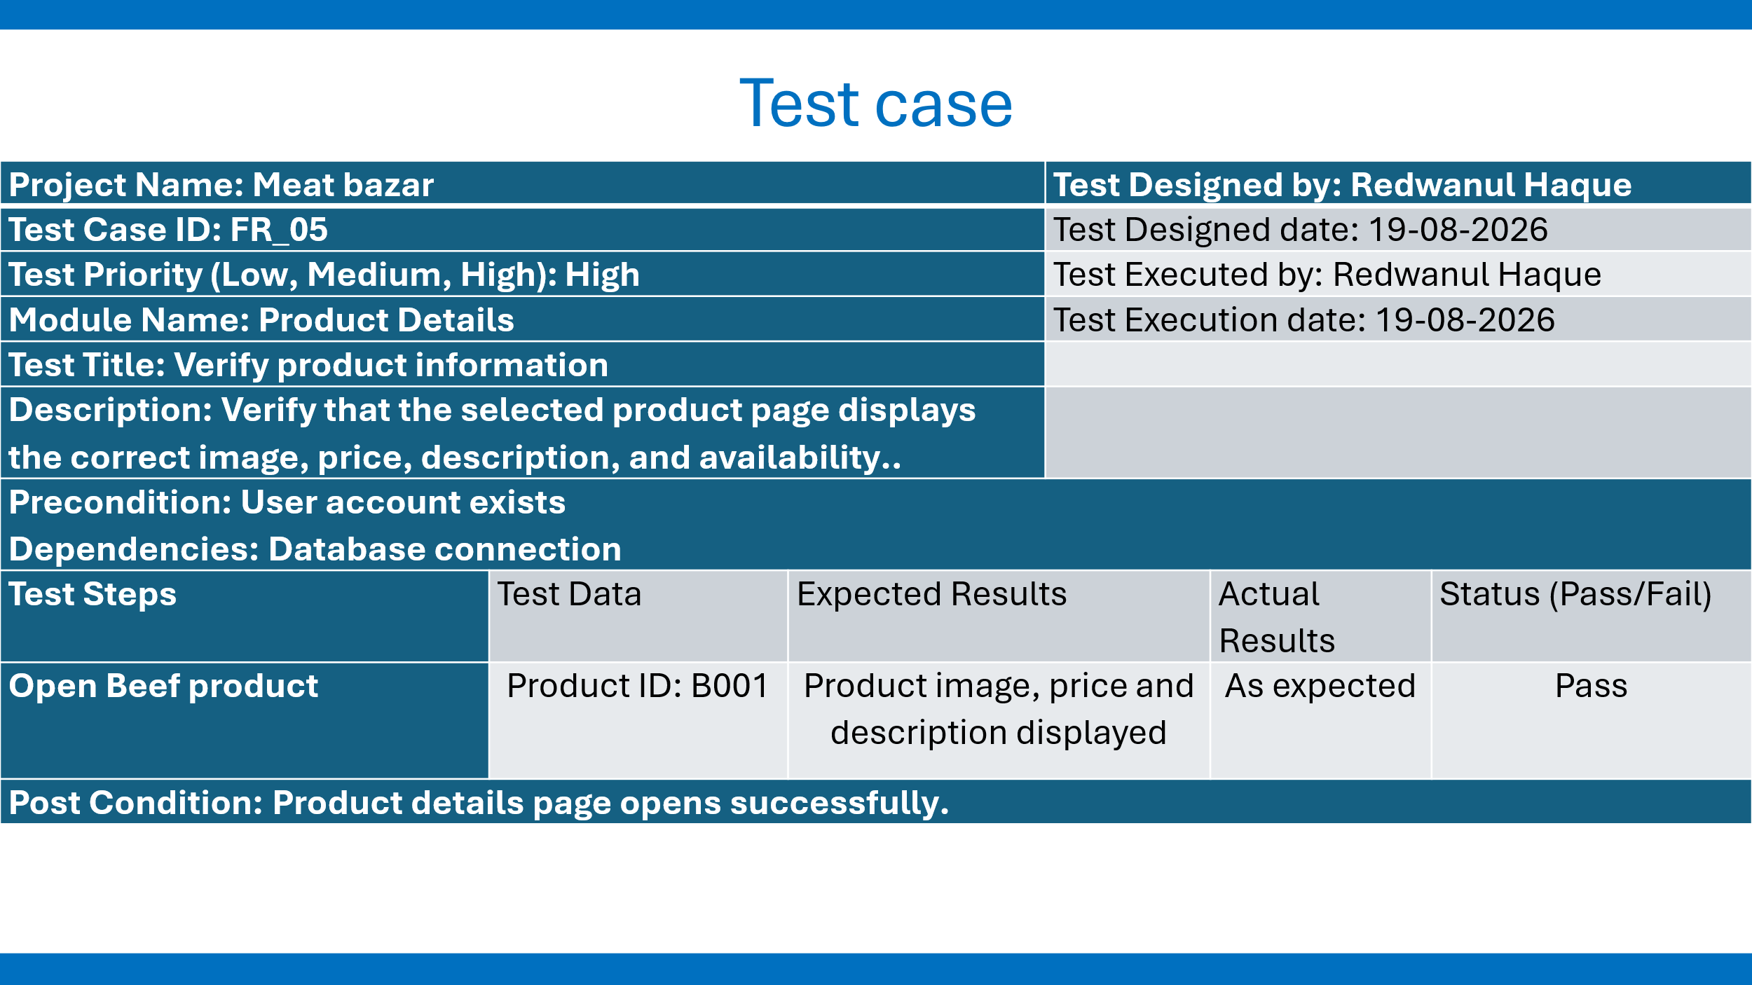
FR_06: Verify Add to Cart
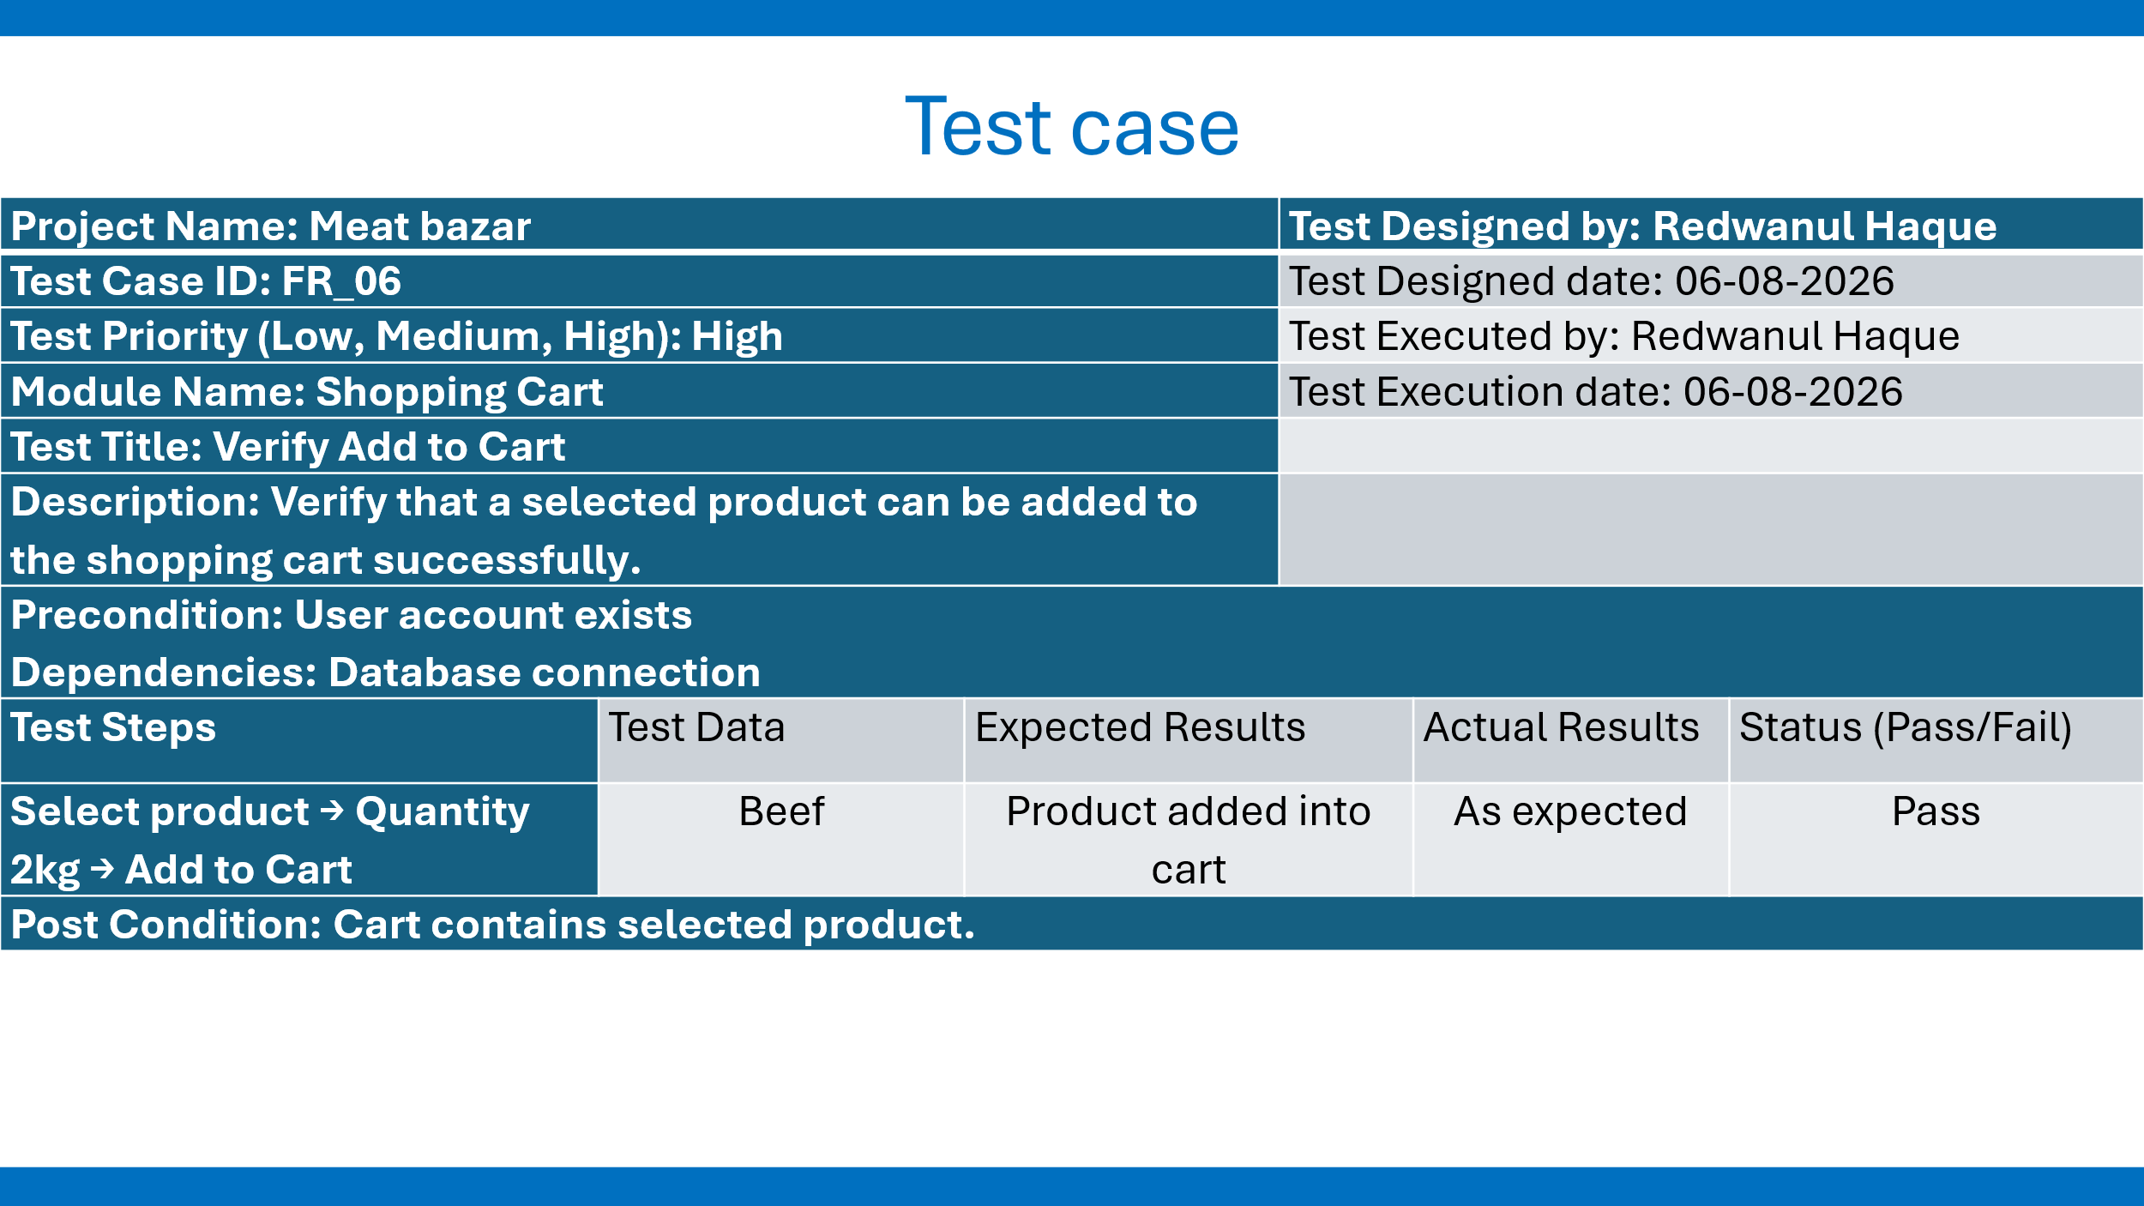

FR_07: Verify Update Cart Quantity
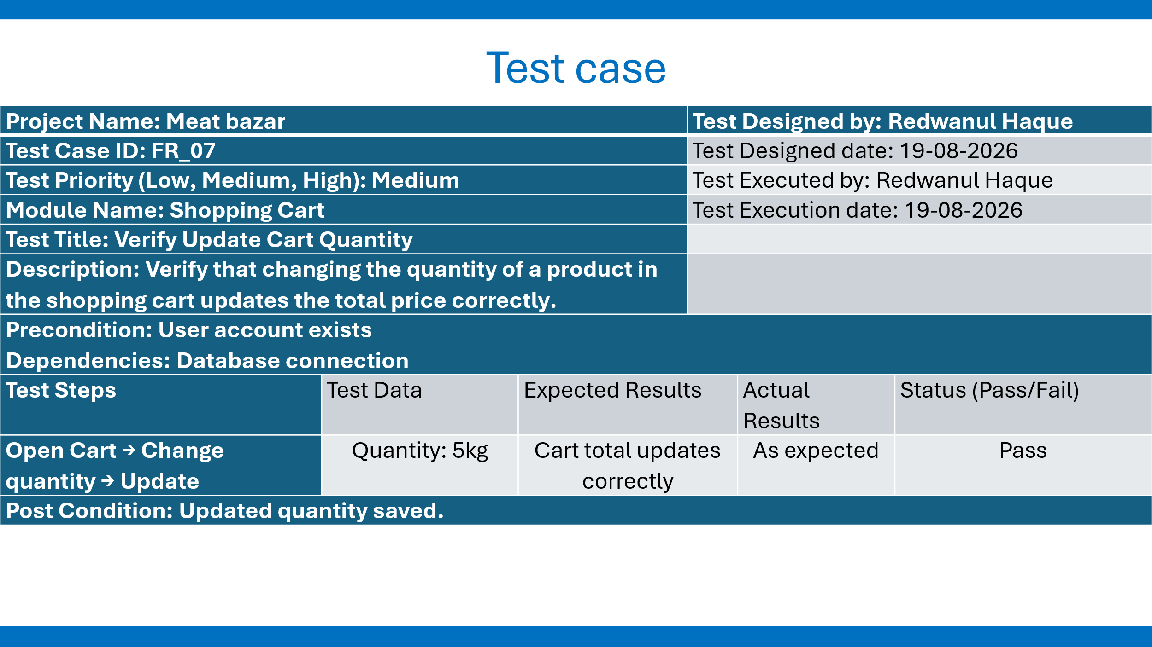

FR_08: Verify Remove Product from Cart
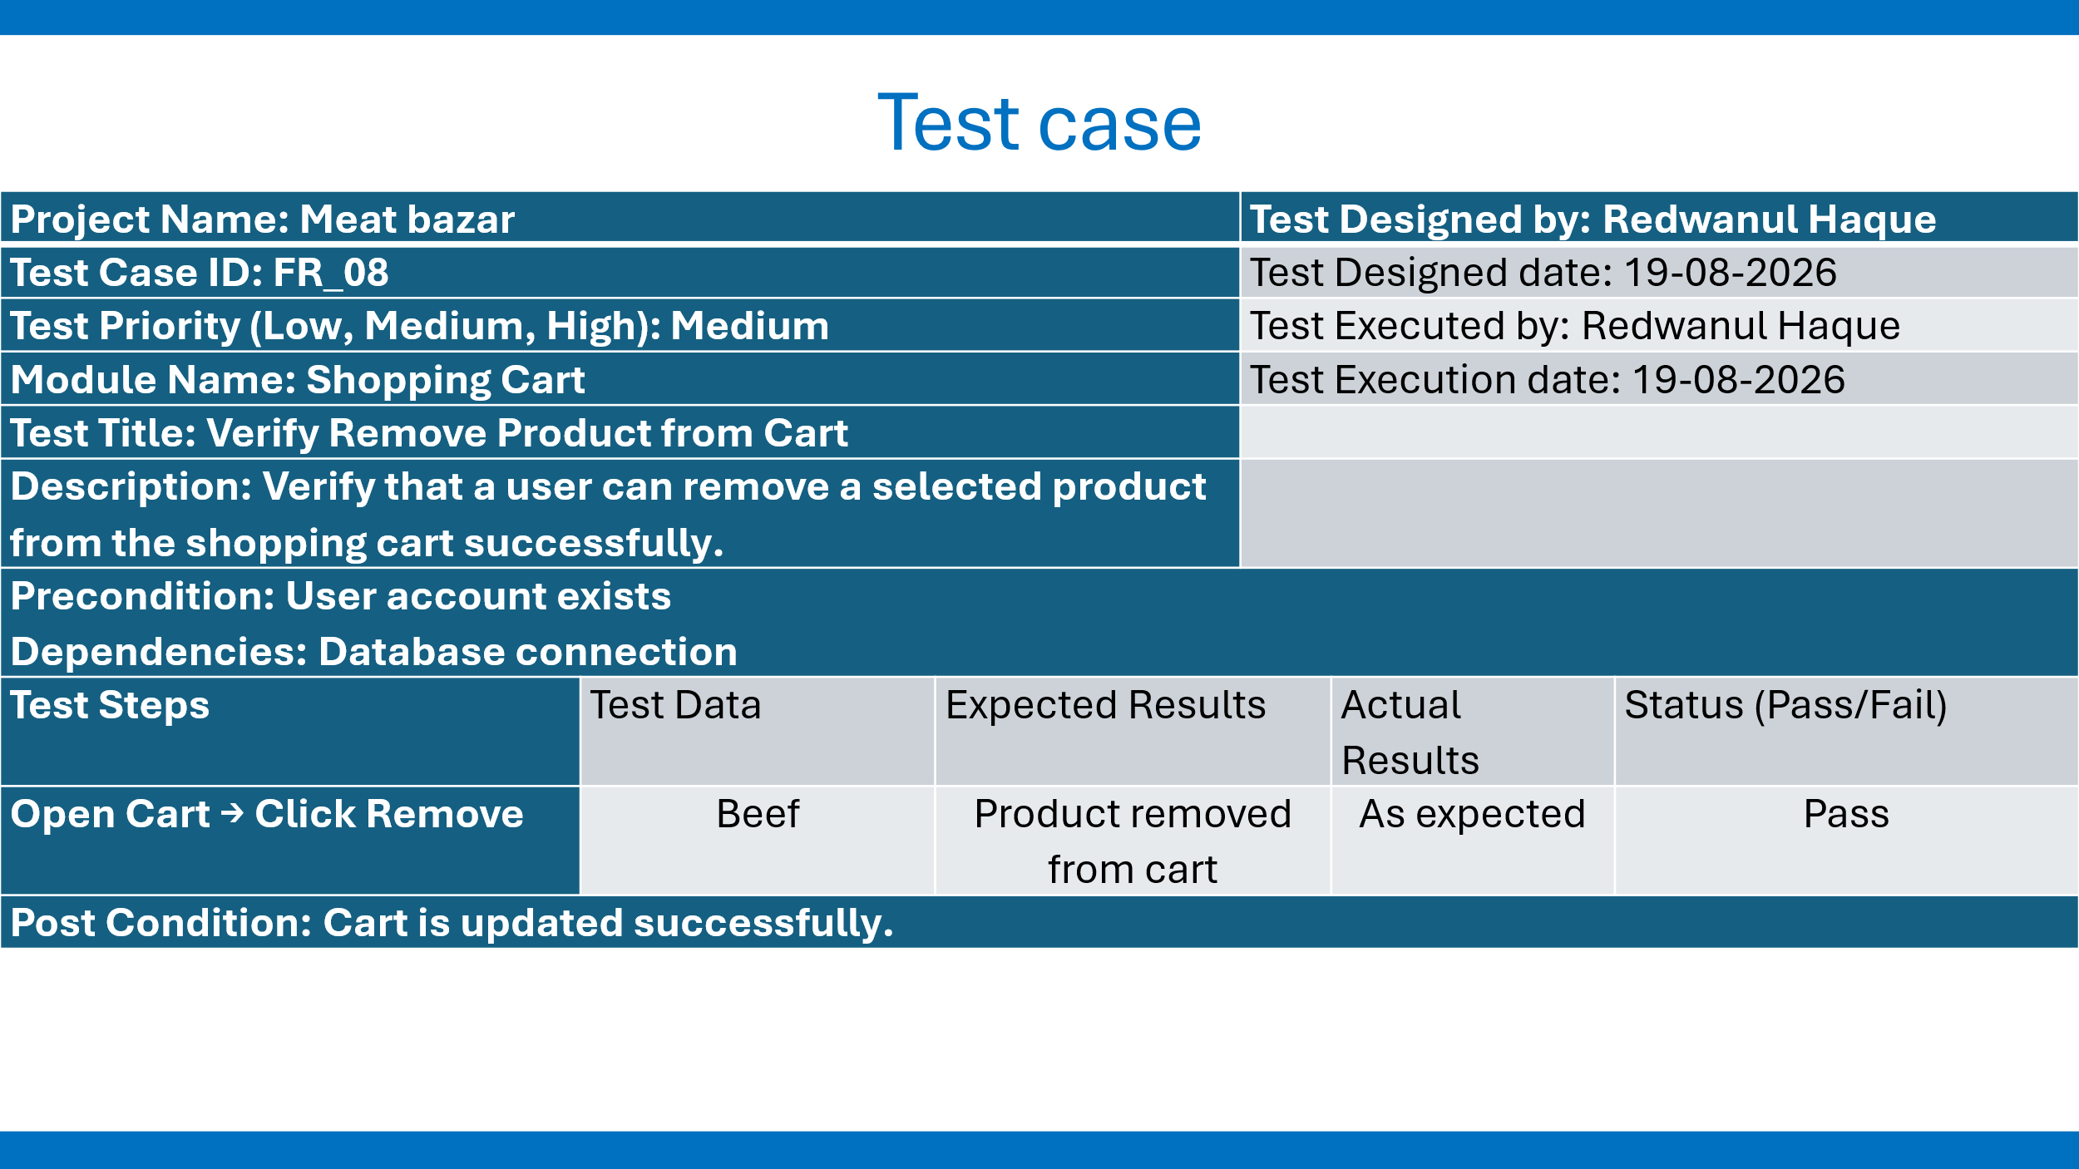

FR_09: Verify Order Placement
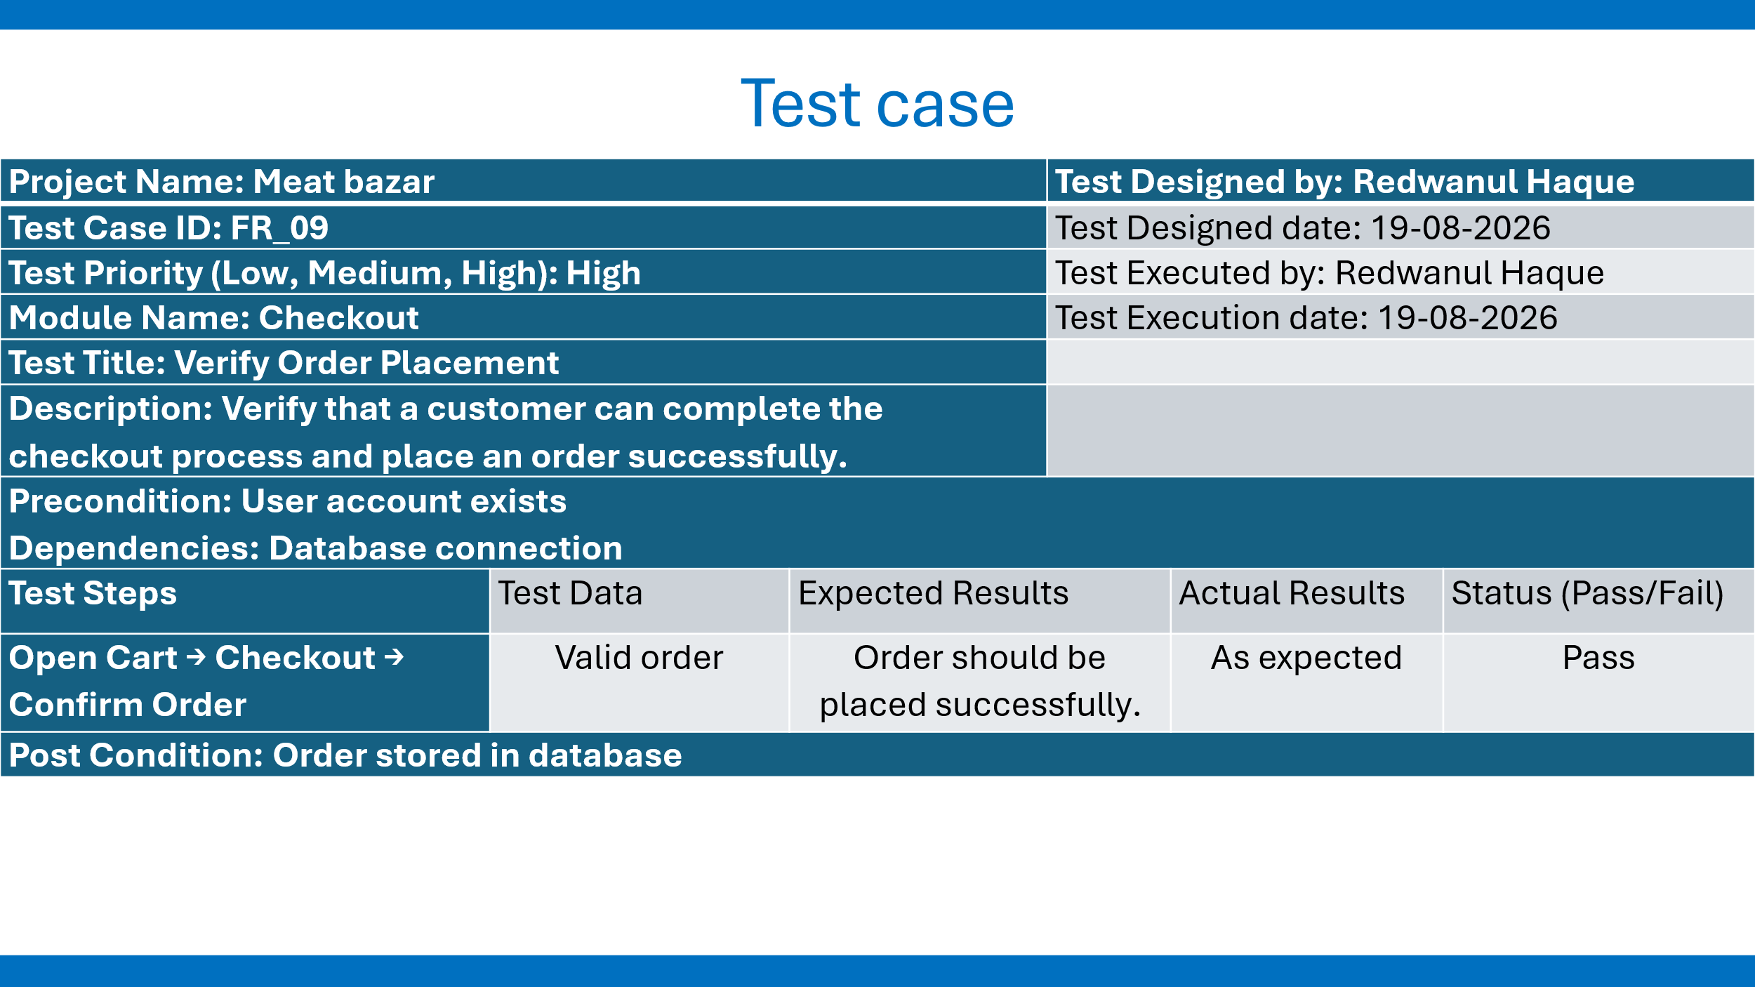

FR_10: Verify payment with valid payment details
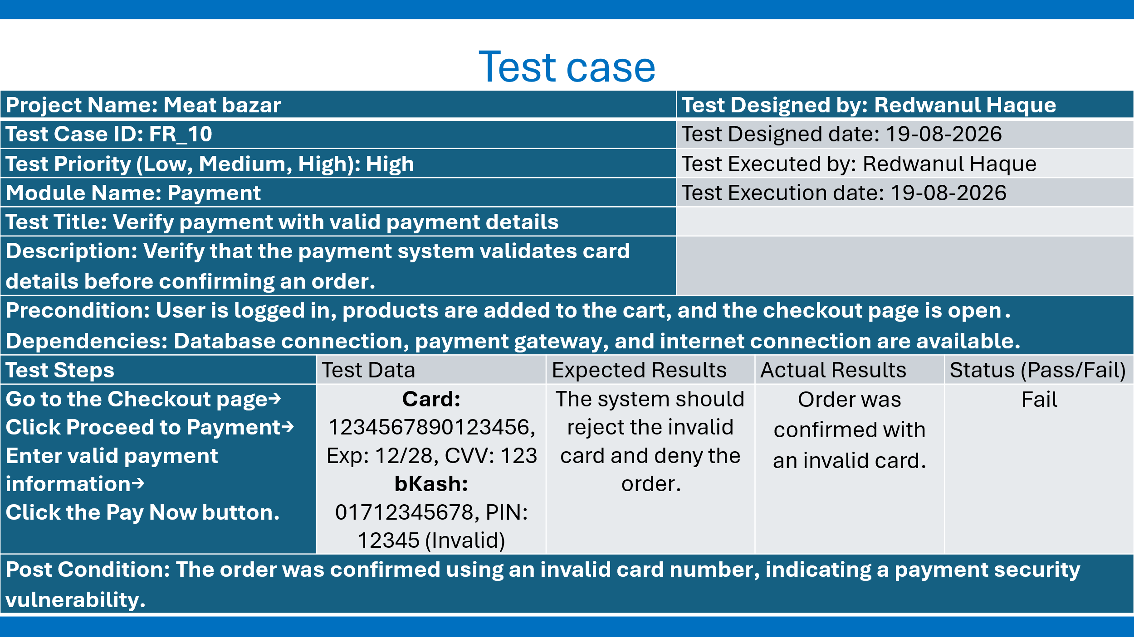
FR_11: Verify order distribution to the customer
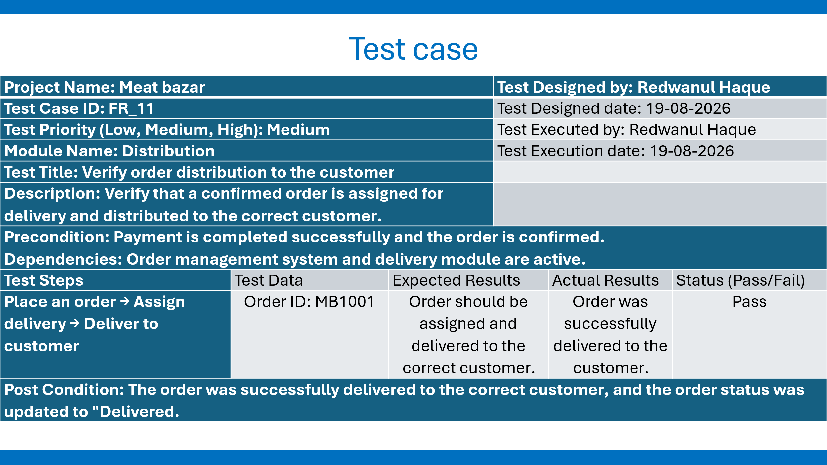

8. ITEM PASS/FAIL CRITERIA
If the actual result is the same as the expected result, the test case passes. The feature is completed as expected. No unhandled error is thrown. Data is correct. A test case fails if it fails to return an expected result, if unauthorized access is possible, if an invalid payment confirms an order, if incorrect totals or order records are produced, or if a serious security/data-integrity problem is found.

9. TEST DELIVERABLES
- Revised Software Test Plan
- Test cases and execution history
- Bug Log with severity and steps to reproduce
- Test summary report
- Requirements Traceability Matrix (RTM)
- Re-test/regression results

10. STAFFING AND TRAINING NEEDS
Project developers and members of the QA/test team are needed for testing. The team members doing browser automation should have basic knowledge of Selenium the automation framework of choice. Testers should also know how PHP/MySQL applications behave, how to use browser developer tools and how to do basic web security validation.

11. RESPONSIBILITIES
Task | Project Team | Developer | Test Team | Stakeholders
Requirement analysis | Lead | Assist | Review | Provide input
Test strategy & planning | Lead | Assist | Lead | Approve
Test case creation | Assist | Assist | Primary | Review
Test execution | Assist | Support | Primary | Observe/accept
Defect fixing | Review | Primary | Verify | —
Regression testing | Assist | Support | Primary | —
Final reporting | Contribute | Technical input | Prepare | Receive/approve

12. TESTING SCHEDULE
Activity | Duration | Description
Test planning & environment setup | 2 days | Finalize test plan and configure XAMPP/database/test data.
Unit testing | 4 days | Test individual functions, validations and calculations.
Integration testing | 5 days | Test interactions among cart, payment, orders, inventory and roles.
System testing | 6 days | Perform end-to-end customer, admin and distributor workflows.
Security & usability testing | 3 days | Check authorization, validation, common web security risks and usability.
Regression & bug fixing | 5 days | Retest fixed defects and verify existing functionality.
Final review | 2 days | Compiled results, final QA documentation.
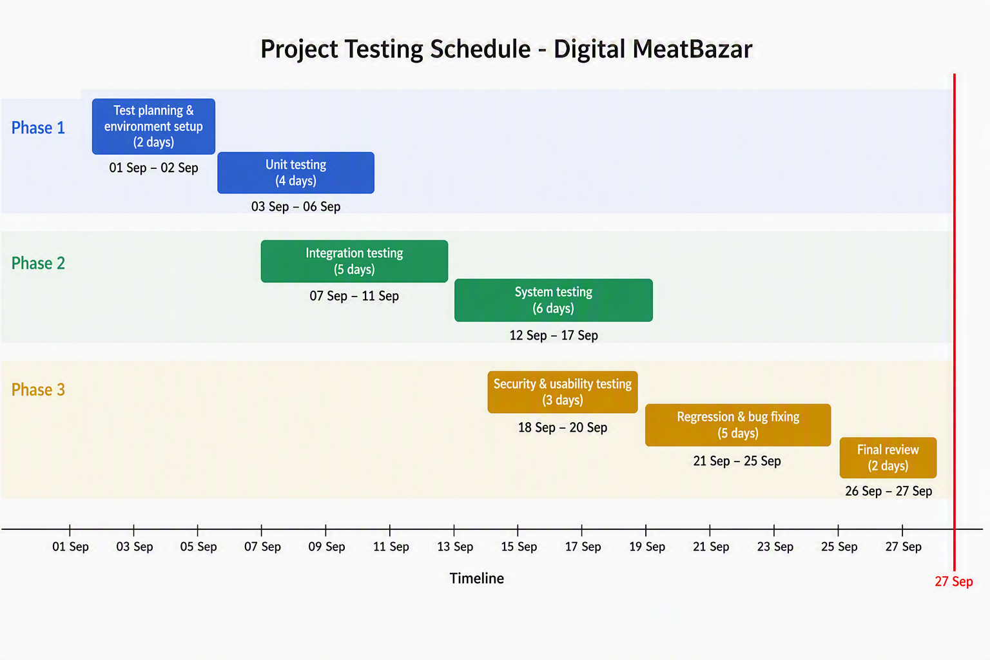

13. PLANNING RISKS AND CONTINGENCIES
Risk | Impact | Contingency
Project changes | Late feature changes may affect test cases and schedule. | Prioritize critical requirements and update affected cases.
Environment issues | XAMPP, PHP or MySQL configuration problems may stop testing. | Prepare the local environment early and maintain a database backup.
Payment validation issues | Incorrect validation could confirm invalid payments. | Use dedicated negative test cases and verify order status/database records.
Data inconsistency | Cart, order or inventory updates may produce inconsistent data. | Verify database state after important transactions.
Role/authorization defects | Users may access functions outside their roles. | Include direct-URL authorization tests for customer, admin and distributor roles.
Defect backlog | Many unresolved defects can delay final testing. | Prioritize critical and major defects first and perform regression testing after fixes.

14. APPROVALS
Role | Name | Signature | Date
Project Sponsor
Project Manager
Test Manager
Team Lead
QA/Test Team
Stakeholder Representative

